# Aim: Creating 2D Infinite Scrolling Background

**Parallax Effect**

With creating multiple scrolling backgrounds with transparency you can create a parallax effect. Just set the scrolling speed of closer objects fast and the scrolling speed of far objects slow. Make sure to set the order layer accordingly in the Inspector. This will add some depth to your game making it look a lot better.

# Here are the steps to create a scrolling background in Unity.

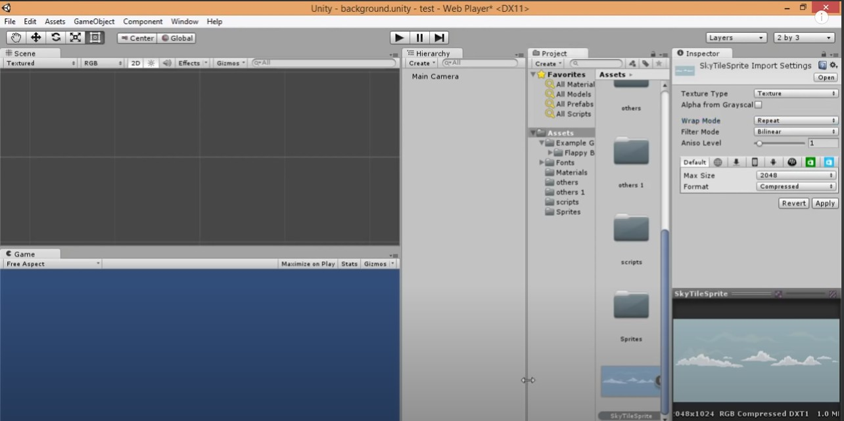STEP 1: Select the image and add it in the asset or scene folder, you will get it on the left side corner. Go to asset —> click on new import →add the image file (png,jpeg).

STEP : 2 Click on image which is added in the asset interface . Go to inspector window (i.e properties of the image )

Select the texture type as **“ texture “** if texture is not there you can use the texture type as

**“default”.**

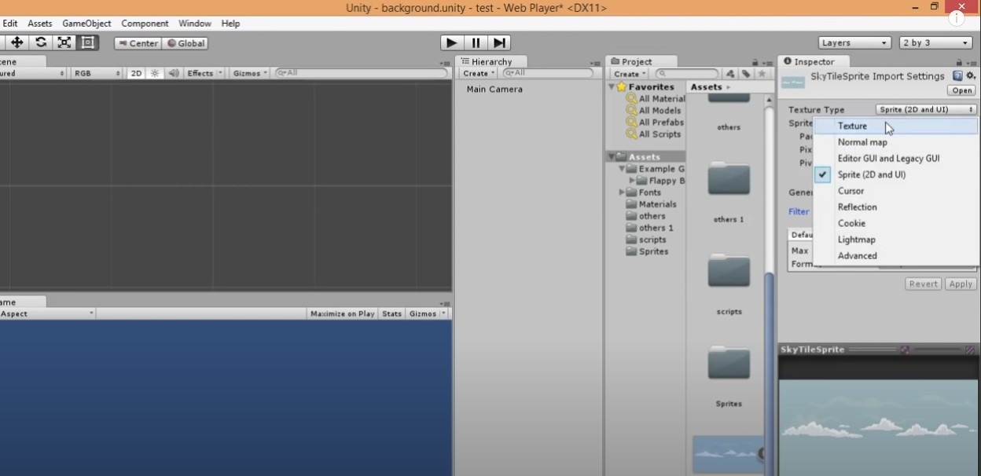

STEP : 3 After Selecting the texture type, change the “Wrap type” as **“repeat”**

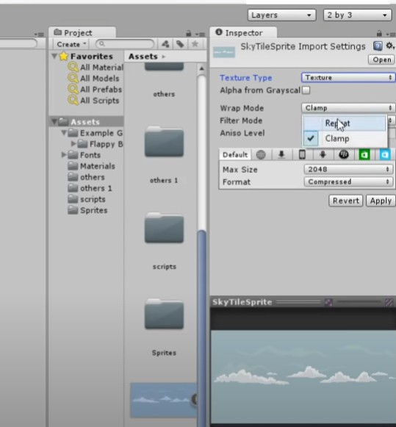

STEP : 4 Once the texture type and Wrap type is changed you have to **Click on “Apply”**

Otherwise the changes will not be incooperated in the scene.

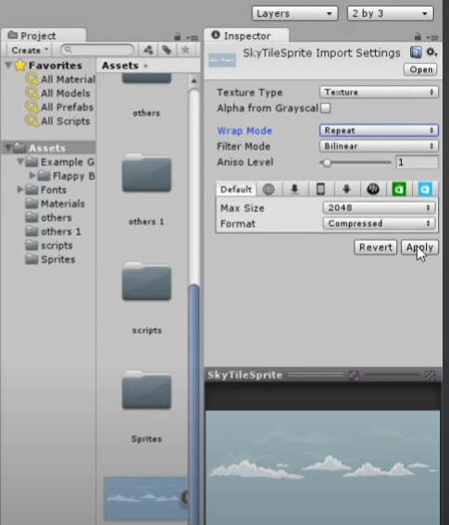

STEP 5: Now to set the frame for background you have to

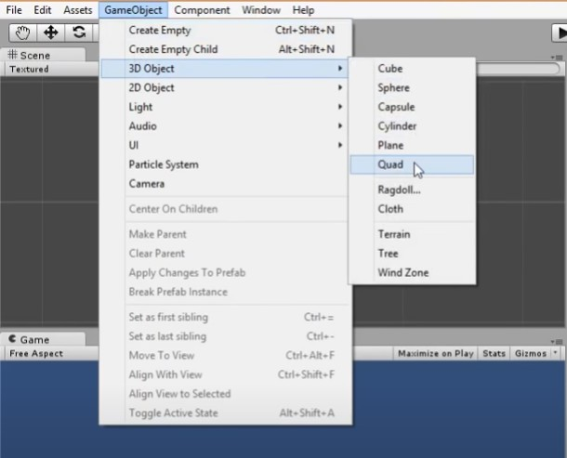Click on Gameobject → 3D object →QUAD → Rename it as “Bcakground” Create a Quad which will decide the size of the backgro

STEP 6 : Increase the size of Quad. you will get from inspector window (properties ) of quad Scale it to x = 20 and y = 10

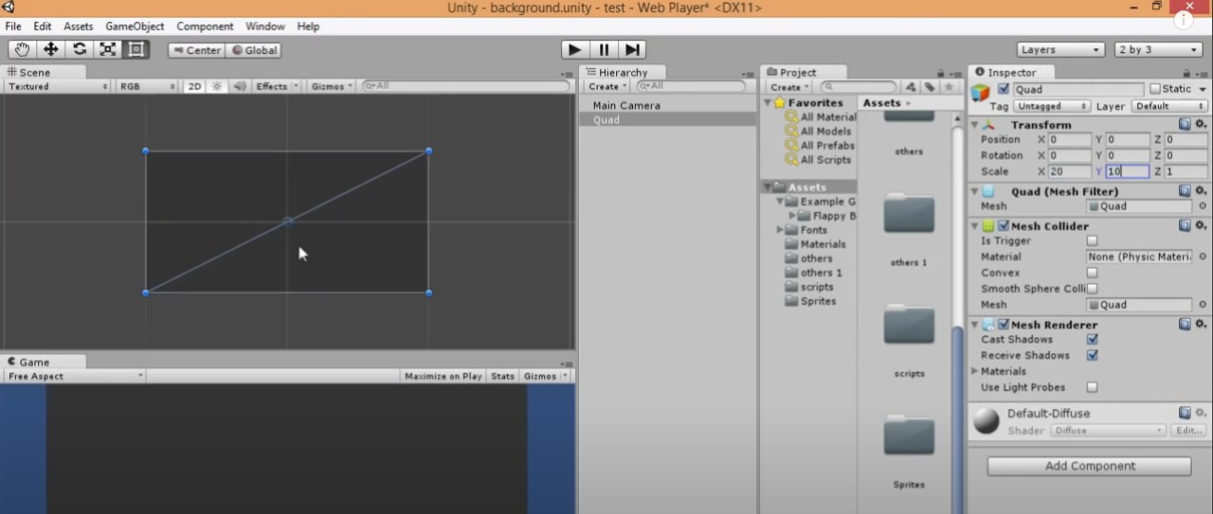

STEP 7: If the background seems to be darker then you can use light, which will help to see the background image properly with bright color.

For that Click on GameObject → light —> directional light.

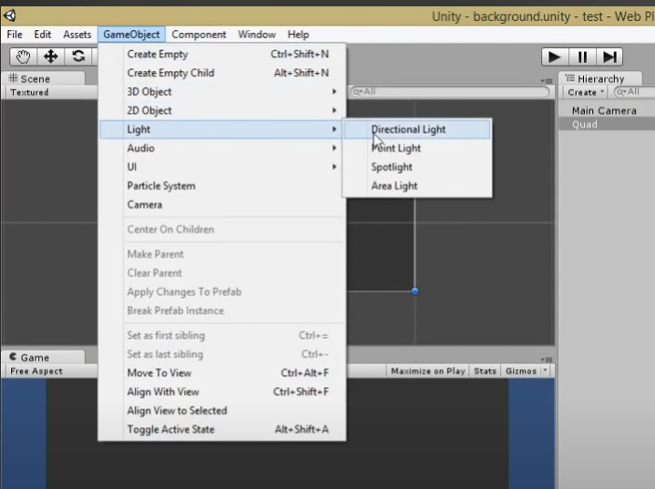

STEP 8: Rename the name for “quad” as “background”

And then drag and drop the background(image that you have added in the asset window).

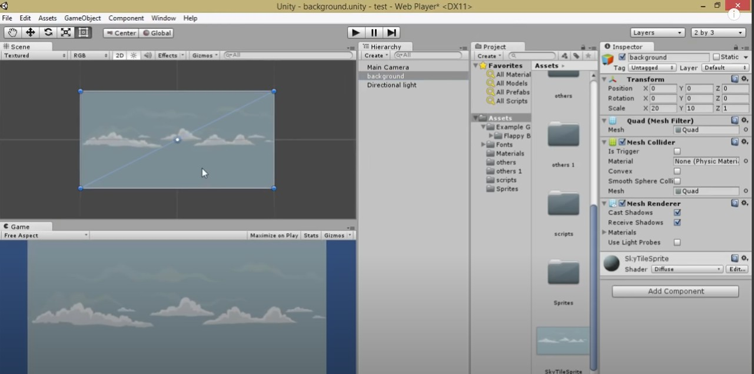

STEP 9 : Adjust the intensity of light to see the bright color.It will be available in the inspector window (properties).

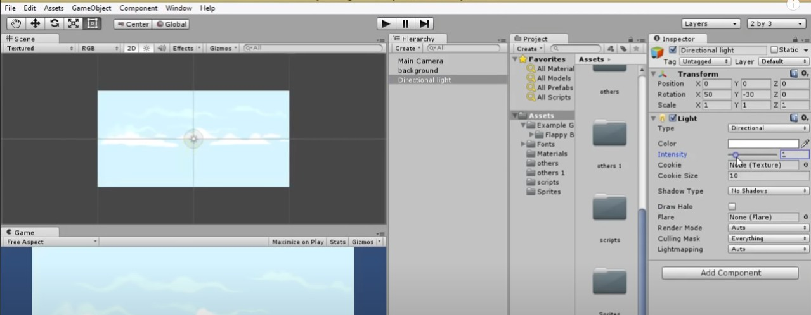

STEP 10: Now we have to write the script to scroll the background. so we have to create asset as script.

click on “Background” (herierachy window ) —> go to Insception Window —> at the end you will get **“ADD COMPONENT”** → click on it —> **script** → new script —> name it —> Click on **“create and add”**

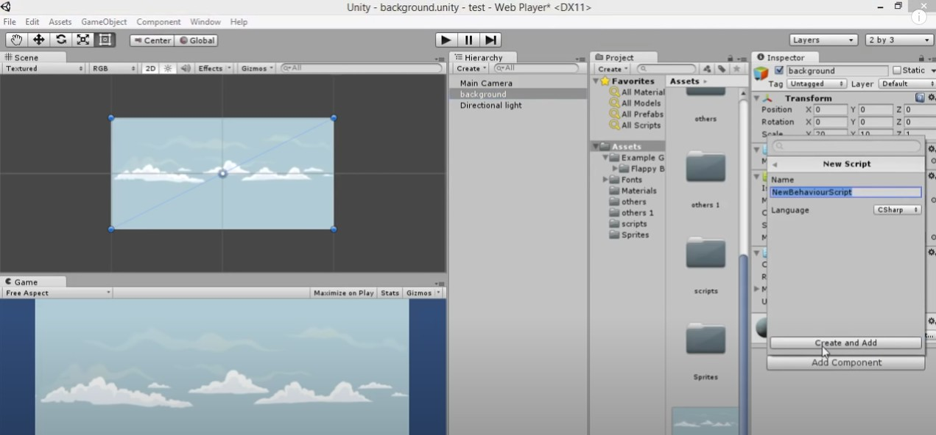

STEP 11 : Click on “script” which is added in the Asset window. By Clicking on it Visual Studio will open write the code for scroller. Next Save the file.

# Component added in the script:

A **Vector2** is typically used to represent a point in 2D space in a Unity game. You can define a Vector2 with two dimensions: Vector2 direction = new Vector2 ( 0.0f , 2.0f );

A **renderer** is what makes an object appear on the screen. Use this class to access the renderer of any object, mesh or Particle System. Renderers can be disabled to make objects invisible (see [enabled](https://docs.unity3d.com/ScriptReference/Renderer-enabled.html)), and the materials can be accessed and modified through them.

An **offset** Sets the depth bias on the GPU. Depth bias, also called depth offset, is a setting on the GPU that determines the depth at which it draws geometry. Adjust the depth bias to force the GPU to draw geometry on top of other geometry that is at the same depth.

**Time** simply gives you a numeric value which is equal to the number of seconds which have elapsed since the project started playing. The value is a 'float', which means that you get exact time including the fraction of the second which is currently elapsing, rather than discrete whole-number seconds.

# Main texture offset

The offset of the main texture. By default, Unity considers a texture with the property name "_MainTex" to be the main texture. Use the [MainTexture] ShaderLab Properties attribute to make Unity consider a texture with a different property name to be the main texture. This is the same as calling Material.

**GetComponent** returns only the first matching component found on the GameObject on which it is called, and the order that the components are checked is not defined. Therefore, if there are more than one of the specified type that could match, and you need to find a specific one, you should use Component.

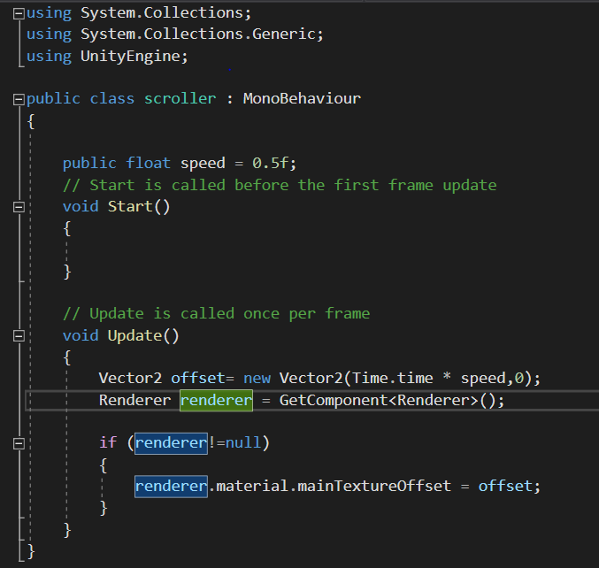

STEP 12 : Once it's done, GO to unity → click on play symbol and play the game.

If there is no error in the code it will be added directly with the scene and the background will start scrolling.

